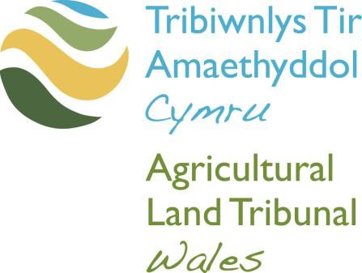

Notice by Applicant under Rule 45 (5) of the Agricultural Land Tribunals Rules 2007

This Application form is also available in Welsh. Please contact the Tribunal for a Welsh version of this form.

The tribunal will accept applications by email to AgriculturalLandTribunalWales@gov.wales or in hard copy by post.
If sending a hard copy, please send the completed application form together with the specified documents to:

Agricultural Land Tribunal Wales
Welsh Tribunals Unit
PO Box 100
Llandrindod Wells
Powys
LD1 9BW

If you have any queries you can contact the Tribunal by email or on 0300 025 9809.

We welcome calls in Welsh and English.

The Agricultural Land Tribunal Wales welcomes correspondence and phone calls in Welsh and English. This includes submitting forms, documents and written representations to the Tribunal.

- 1. Language Preference
Would you prefer to correspond with us in: | Welsh ☐  English ☐  Both ☐
Would you prefer any verbal communication to be in: | Welsh ☐  English ☐  Both ☐
Would you prefer to speak Welsh or English at your Tribunal Hearing? | Welsh ☐  English ☐  Both ☐
2. Languages Spoken
What languages do you use to communicate?  (Please tick all that apply) | Welsh ☐  English ☐  Other (please state) ☐
 | Click or tap here to enter text.
- 3. We would like to support the use of the Welsh language in Tribunals. If you can speak Welsh, and have indicated English as your language of choice, is there a specific reason why you have chosen to communicate in English? | (Your answer will not affect the substance of your case in any way)
Click or tap here to enter text.

Section 1 – Information about You

Full Name | Click or tap here to enter text.
Address (including Postcode) | Click or tap here to enter text.
Telephone Number | Click or tap here to enter text.
Email Address | Click or tap here to enter text.

Section 2 – Information about the Application Made

Tribunal Number | ALTClick or tap here to enter text.
Name of Applicant | Click or tap here to enter text.
Address of Holding | Click or tap here to enter text.

Section 3 – Response to the Technical Report

☐ I accept the contents of the Technical Report

☐ I dispute the following facts and matters contained in the Technical Report, for the reasons set out below:

Click or tap here to enter text.

☐ I accept the recommendation(s) made in the Report and hereby request the Tribunal to make an Order on my Application in the terms of the recommendation(s)

☐ I do not accept the recommendation(s) made in the Report and I request the Tribunal to make an order on my Application in the terms set out in my Application (or in the following modified terms which I detail below):

Click or tap here to enter text.

Section 4 – Statement of Truth

I believe (the Applicant believes) that the facts stated in this document are true.

☐ I am duly authorised by the Applicant to sign this statement

Full Name | Click or tap here to enter text.
Name of Applicant’s Solicitor/Agents firm, if applicable | Click or tap here to enter text.
Date | Click or tap to enter a date.
Signature | Click or tap here to enter text.

